**Assisted Practice: 3.8 Pipes**

This section will guide you to:

* Implement pipes in Angular

This lab has three subsections, namely:

3.8.1 Use built-in Angular pipes

3.8.2 Use custom Angular pipes

3.8.3 Pushing the code to Github repositories

**Step 3.8.1:** Using built-in Angular pipes

* Open Visual Studio Code
* Set product name to uppercase using in-built pipe in *Product-list.component.html*.

<td [style.color]="'#306A9D'" [style.font-weight]="700" [style.font-size.px]="20">

{{ product.productName | uppercase }}

</td>

**Output:**

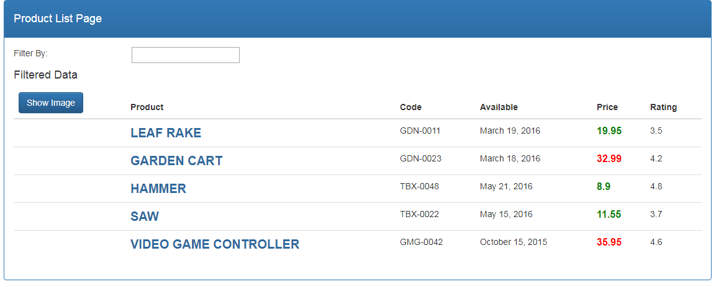

**Step 3.8.2:** Using custom Angular pipes

* Create a new file called *convert-to-spaces.pipe.ts***.**

import { Pipe, PipeTransform } from "@angular/core";

@Pipe({

name: 'convertToSpaces'

})

export class ConvertToSpacesPipe implements PipeTransform{

transform(value:string, character:string, ) {

return value.replace(character, '@');

}

}

* Import *convert-to-spaces.pipe.ts* to *app.module.ts* and declare it inside declaration array.

import { ConvertToSpacesPipe } from 'src/app/products/convert-to-spaces.pipe';

declarations: [

AppComponent,

ProductListComponent,

ConvertToSpacesPipe

]

* Add the following code in *Product-list.component.html*.

<td>{{ product.productCode | convertToSpaces:'-'}}</td>

**Output:**

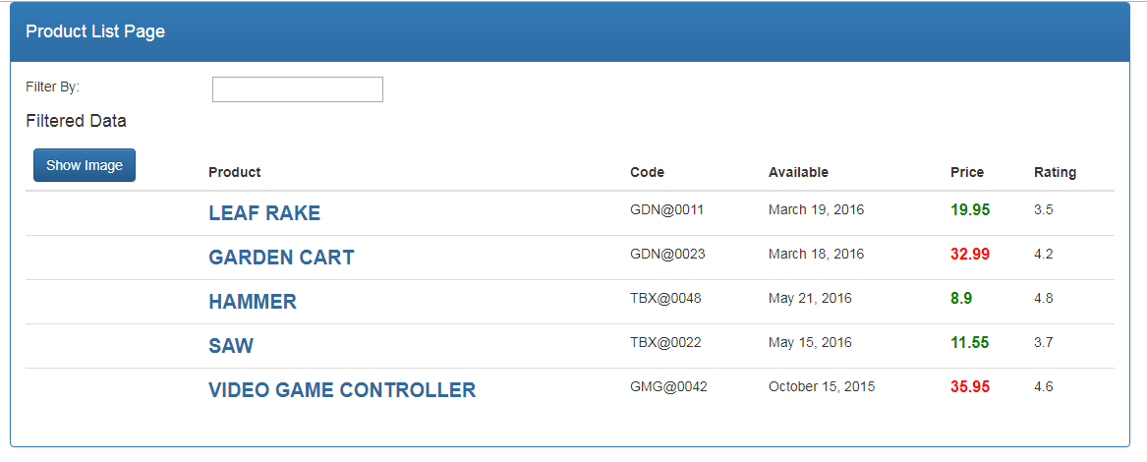

**Step 3.8.3:** Pushing the code to your GitHub repositories

* Open your command prompt and navigate to the folder where you have created your files.

**cd <folder path>**

* Initialize your repository using the following command:

**git init**

* Add all the files to your git repository using the following command:

**git add .**

* Commit the changes using the following command:

**git commit . -m “Changes have been committed.”**

* Push the files to the folder you initially created using the following command:

**git push -u origin master**